**Introduction**

This report aims to identify and critique visualisations that centre on climate change, the atmosphere specifically, based on predefined quality criteria. Using the criteria, we are able to evaluate the visualisations, point out the areas needing improvement, and then make necessary recommendations for improving them.

**Quality Criteria**

Listed below are the visualisations relating to climate change. The visualisations are selected from wide range of sources which will be provided along with the graphs below. They are to be critiqued, with due recommendations made on improving them.

**Criteria 1**

A visualization should have a zero baseline.

**Reasoning**

According to Knaflic (2015), though a data analyst can get away with a nonzero baseline, caution should however be taken when doing that. This is because if there is a minor change, it can cause a significant change. So you should ensure your graph has a zero baseline. If you want to use make a graph with a nonzero baseline, then you have to make it clear to your audience and also take into account the context.

**Criteria 2**

Colours should not be misuse or overused.

**Reasoning**

Colour choices should be made thoughtfully, with an understanding of how we perceive colour and the significance of colour differences (Few, 2006). According to Tufte (1983), inept graphics also flourish because many graphic artists believe that statistics are boring and tedious. It then follows that decorated graphics must pep up, animate, and all too often exaggerate what evidence there is in the data. We tend to believe using colours such as red, yellow and green can help convey a message to our audience through the data, but in doing so we exclude the 10% of males and 1% of females who are colour‐blind (Few, 2006). Avoid the use of bright colours except to highlight particular datastick with more subdued colours for most of what's displayed. Use a background colour that is slightly off‐white to avoid the stark contrast between foreground colours against a pure white background (Few, 2006). Colours should be used sparingly (Knaflic, 2015). According to Stone, colour used well can enhance and clarify a presentation. Colour used poorly will obscure, muddle, and confuse.

**Criteria 3**

Maximize data-ink ratio of your chart

**Reasoning**

According to Tufte, 1983, a large share of ink on a graphic should present data‐information, the ink changing as the data change. Data‐ink is the non‐erasable core of a graphic, the non-redundant ink arranged in response to variation in the numbers represented. Then,

Duarte (2010) referred to the same concept as signal-to-noise ratio. According to her, the signal is the information we want to communicate, and the noise are those elements that either don’t add to or in some cases detract from, the message we are trying to impart to our audience (Knaflic, 2015).

**Criteria 4**

Cluttering should be avoided

Remove anything that is not adding relevant information or is not adding enough informative value in the space it occupies (Knaflic, 2015). According to Knaflic (2015), clusters should be avoided totally. Pie chart has a lot of clutter, and it is not a good way of telling a data story (Knaflic, 2015). According to Tufte, overload, clutter, and confusion are not attributes of information, they are failures design.

**Criteria 5**

The use of data markers are unnecessary

According to Knaflic (2015), every single elements add cognitive load on the part of your audience. If you have to use data markers, use them on purpose and with a purpose, rather than because their inclusion is your graphing application’s default.

**Criteria 6**

All axes should be labelled in simple and easy to understand terms. Scales should also be correctly illustrated.

**Rationale**

According to Knaflic (2015), the use of secondary y-axis is generally not a good idea. Knaflic (2015) also suggests that labels should be added directly.

**Portfolio**

Graph1: Information visualization showing the atmospheric concentration of carbon dioxide (C02)

Graph 2: Surprise, the world was warmer again in 2017

Graph 3: Top 10 Greenhouse Gas emitters 2016

Graph 4: Air pollution in cigarette

Graph 5: The relentless rise of carbon dioxide

Graph 6: Annual C02 emissions from fossil fuels, by world region

Graph 7: Keeling curve showing carbon dioxide concentrations

Graph 8: Carbon emissions goal vs. current paths

Graph 9: How fast emissions would reduce if other plans were adopted

Graph 10: Global temperature vs. number of pirates

Graph 1: The first chart is a line chart that shows the atmospheric concentration of carbon dioxide (C02). The x-axis shows the years, while the y-axis shows the amount of carbon dioxide (C02) concentrated in the atmosphere in those years. The visual was designed for the general audience, so that they can see at a glance how carbon dioxide (C02) is concentrated in the atmosphere over the years.

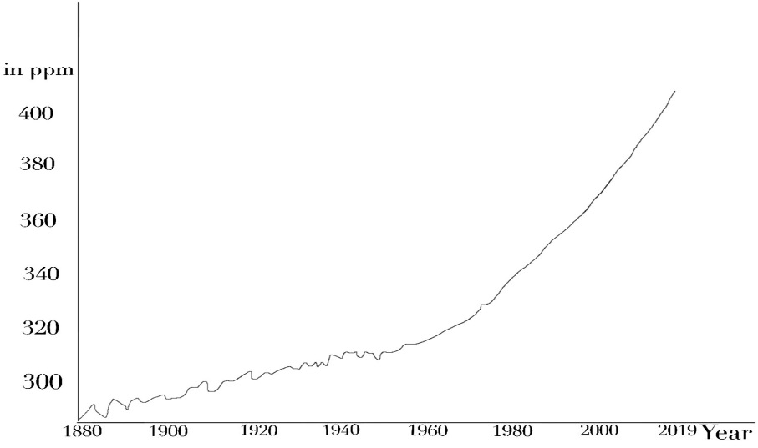

**Evaluation**

**Criteria 1**

A visualization should have a zero baseline.

* The Y-axis and X-axis are well-labelled.
* The X-axis however does not have a zero base line.
* Ticks were not used on both the X-axis and Y-axis

**Criteria 2**

Colours should not be misuse or overused

* This criteria does not apply in this visual

**Criteria 3**

Maximize data-ink ratio of your chart

* The data-ink ratio of the graph was maximised well enough

**Criteria 4**

Cluttering should be avoided

* This criteria does not apply in this graph

**Criteria 5**

The use of data markers are unnecessary

* This criteria does not apply in this graph

**Criteria 6**

All axes should be labelled in simple and easy to understand terms. Scales should also be correctly illustrated.

* The axes labels of this graph are easy to understand

**Recommendations**

The graph should be made to have a zero baseline, so as not to confuse an observer of the graph.

Graph2: Surprise, the world was warmer again in 2017

This graph shows that the world has been warmer again in 2017, rather surprisingly. The graph was obtained from Nathan Yau’s Flowing Data website, but was originally made available by NASA. It is meant for an observer to see how warmer the world has been in the 2017

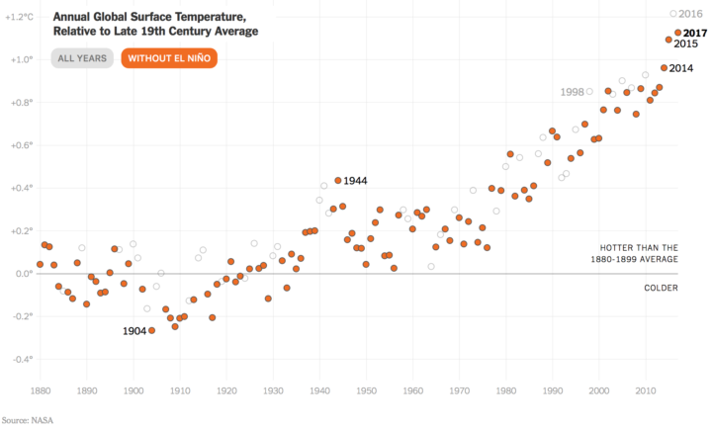

**Evaluation**

**Criteria 1**

A graph should have a zero baseline.

* The graph as a zero baseline. This helps an audience to understand the message better. An audience will be able to see how the world temperature has risen or declined over the number of years observed.

**Criteria 2**

Colours should not be misused or overused.

* The colours used in the graph are blended properly.
* The colours have been properly selected to ensure people with colour blindness do not have difficulty reading the graph.

**Criteria 3**

Maximize data-ink ratio of your chart

* This criteria does not apply in this graph

**Criteria 4**

Cluttering should be avoided

* The information presented on this graph are not cluttered. They are presented in such a way as to highlight important points on the graph.

**Criteria 5**

The use of data markers are unnecessary

* This criteria does not apply in this graph

**Criteria 6**

All axes should be labelled in simple and easy to understand terms. Scales should also be correctly illustrated.

* The Y-axis and the X-axis are not labelled.

**Recommendation**

The axes of the graph should be properly labelled.

Graph 3: Top 10 Greenhouse Gas emitters 2016

This graph shows the top 10 Greenhouse Gas emitter for the year 2016. It is gotten from the World Research Institute. It is made for the consumption of the adult population; the government and keen observers of the environment.

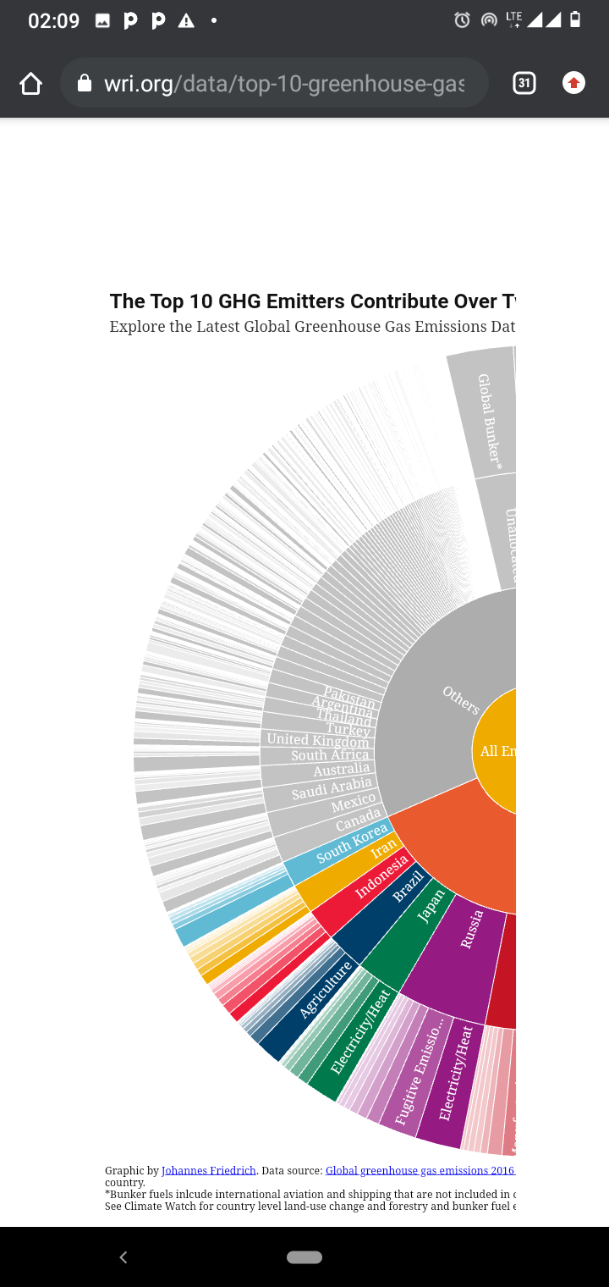

**Evaluation**

**Criteria 1**

A graph should have a zero baseline.

**Criteria 2**

Colours should not be misuse or overused.

* There is excessive white colour in different part of the graph.

**Criteria 3**

Maximize data-ink ratio of your chart

* This criteria does not apply in this graph

**Criteria 4**

Cluttering should be avoided

* Too many information is cluttered on the graph

**Criteria 5**

The use of data markers are unnecessary

* This criteria does not apply in this graph

**Criteria 6**

All axes should be labelled in simple and easy to understand terms. Scales should also be correctly illustrated.

* This criteria does not apply in this graph

**Recommendations**

* The graph should contain less amount of information, concentrating on the important aspects alone.
* The excessive white colour in the graph should be reduced

Graph 4: Air pollution in cigarette

This graph shows air pollution caused by cigarette. It emphasises how smoke from cigarette has contributed to air pollution. The graph is obtained from earth.org. It is made for the adult populace to observe the effect of smoking can have in the environment.

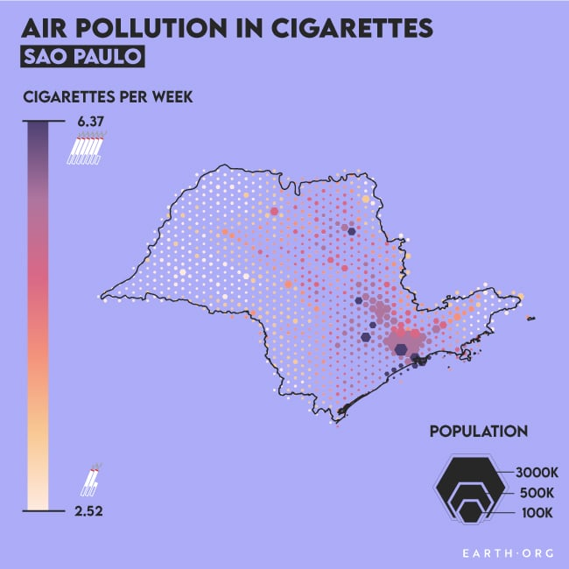

**Evaluation**

**Criteria 1**

A graph should have a zero baseline.

* This criteria does not apply in this graph

**Criteria 2**

Colours should not be misuse or overused.

* The colours have been carefully selected to convey the information on the graph

**Criteria 3**

Maximize data-ink ratio of your chart

* This criteria does not apply in this graph

**Criteria 4**

Cluttering should be avoided

* The information are not cluttered. Items have been carefully positioned on the graph.

**Criteria 5**

The use of data markers are unnecessary

* Data marker was used appropriately in this graph

**Criteria 6**

All axes should be labelled in simple and easy to understand terms. Scales should also be correctly illustrated.

* This criteria does not apply in this graph

**Recommendations**

The symbol representing cigarette in this graph should be increased in order to improve readability.

Graph 5: The relentless rise of carbon dioxide

This graph depicts the rise of carbon dioxide over the years. The graph is made available by NASA. Its target audience are adult who should understand how carbon dioxide has risen over time. It is also calling the attention of world leaders to the rise of carbon dioxide into the atmosphere.

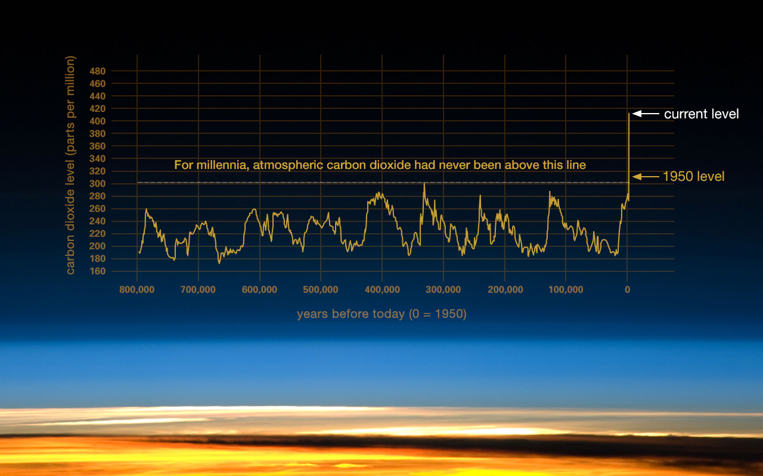

**Criteria 1**

A visualization should have a zero baseline.

* This graph does not have a zero baseline. Care needs to be taken to ensure they are nor misinterpreted.

**Criteria 2**

Colours should not be misuse or overused.

* This criteria is not applicable to this graph

**Criteria 3**

Maximize data-ink ratio of your chart

* The data to ink ratio is not maximized. A large portion of the data is empty, showing no information at all.

**Criteria 4**

Cluttering should be avoided

* The values of the Y-axis seem to be cluttered. This does not allow for readability.

**Criteria 5**

The use of data markers are unnecessary

* This criteria is not applicable to this chart

**Criteria 6**

All axes should be labelled in simple and easy to understand terms. Scales should also be correctly illustrated.

* Both axes are labelled properly to show what they represent.

**Recommendation**

* The graph should be given a zero baseline
* The data-to-ink ratio of the graph should be maximized

Graph 6: Annual C02 emissions from fossil fuels, by world region

This graph shows annual C02 emissions from fossil fuels, by world region. It is obtained from Our World in Data. It is calling attention of everyone to the CO2 emitted from fossil fuels by different regions of the world.

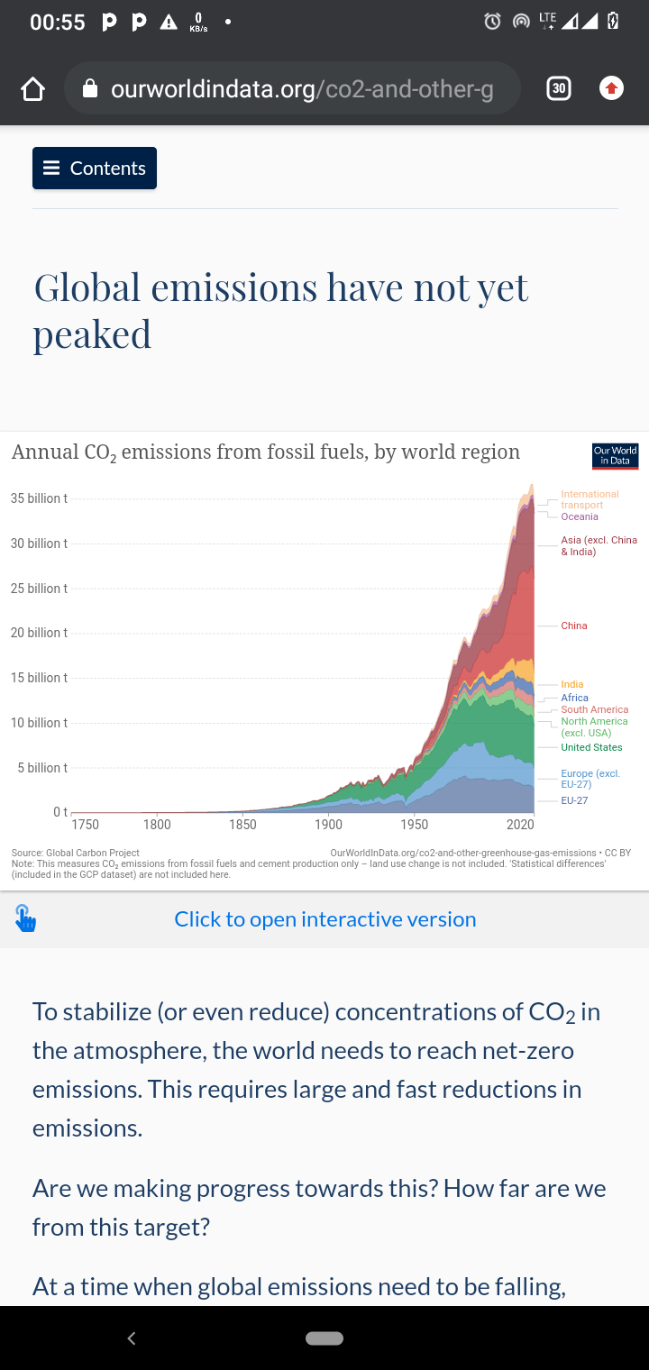

**Evaluation**

**Criteria 1**

A graph should have a zero baseline.

* This graph has a zero baseline. This aids the reader in understanding the starting point of the chart

**Criteria 2**

Colours should not be misuse or overused.

* Colours are properly combined in this graph to show what each segment represent.

**Criteria 3**

Maximize data-ink ratio of your chart

* The data-to-ink ratio of the chart was well maximized

**Criteria 4**

Cluttering should be avoided

* Too much information is cluttered on this chart, though it allows for readability. But only important information should be revealed by a chart.

**Criteria 5**

The use of data markers are unnecessary

* There are more than necessary markers on this chart.

**Criteria 6**

All axes should be labelled in simple and easy to understand terms. Scales should also be correctly illustrated.

* The axes of this chart are labelled properly. This enables an audience to understand they represent.

**Recommendation**

* The graph should be de-cluttered, so that it shows only important information.
* The markers should be reduced. This will make the chart more readable.

Graph 7: Keeling curve showing carbon dioxide concentrations

This keeling curve is used to show carbon dioxide concentrations. The graph is obtained from Nighingaledvs. The target audience for the graph are the adult population and the government of different nations.

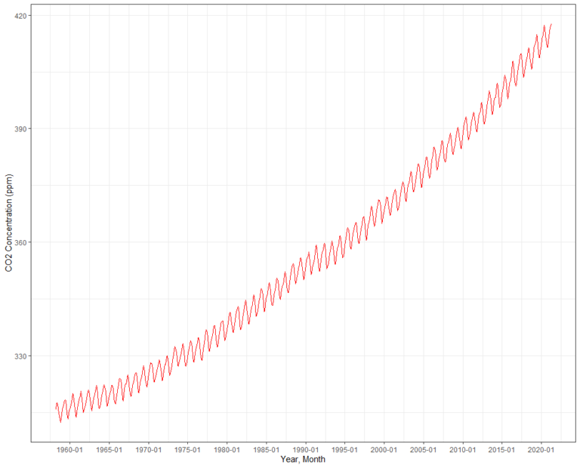

**Evaluation**

**Criteria 1**

A graph should have a zero baseline.

* This graph lacks a zero baseline. This may cause an audience to misinterpret the graph.

**Criteria 2**

Colours should not be misuse or overused.

* A single colour is used to represent the curve on the graph.

**Criteria 3**

Maximize data-ink ratio of your chart

* This criteria is not applicable to this graph.

**Criteria 4**

Cluttering should be avoided

* Cluttering does not occur in this chart

**Criteria 5**

The use of data markers are unnecessary

* This criteria is not applicable to this graph.

**Criteria 6**

All axes should be labelled in simple and easy to understand terms. Scales should also be correctly illustrated.

* The Y-axis and X-axis of this graph is labelled properly.

**Recommendation**

* To avoid been misinterpreted, this graph should be given a zero baseline.

Graph 8: Carbon emissions goal vs. current paths

This is a graph of carbon emission goals vs. current paths in the United States. It is calling the attention of the U.S. government to the variance in the carbon emission goal and the current paths. The is taken from Flowing Data.

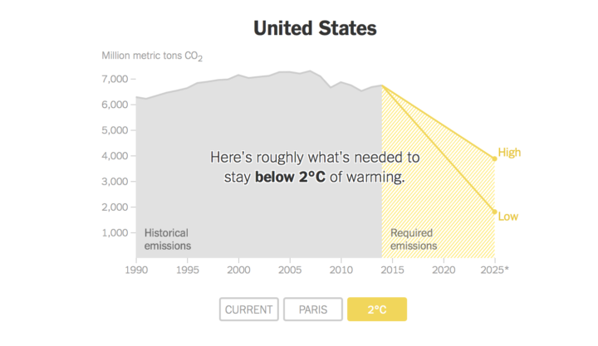

**Evaluation**

**Criteria 1**

A graph should have a zero baseline.

* This criteria is not applicable to this graph.

**Criteria 2**

Colours should not be misuse or overused.

* Colours have been combined properly to ensure the graph does not wear out the reader’s eyes.

**Criteria 3**

Maximize data-ink ratio of your chart

* The data-to-ink ratio of the data was well maximized.

**Criteria 4**

Cluttering should be avoided

* This graph does not have information cluttered on it.

**Criteria 5**

The use of data markers are unnecessary

* This criteria is not applicable to this graph.

**Criteria 6**

All axes should be labelled in simple and easy to understand terms. Scales should also be correctly illustrated.

* The axis of the graph are well-labelled. The scale are also correctly illustrated.

**Recommendations**

* A zero baseline can be added to the graph to ensure they are not misinterpreted by the reader.

Graph 9: How fast emissions would reduce if other plans were adopted

This graph tells a reader how fast emissions would reduce if other plans were adopted. It was obtained from Flowing Data.

The graph calls the attention of U.S. citizens and government to the rate at which emissions will reduce if other plans, rather than the status quo, can be adopted.

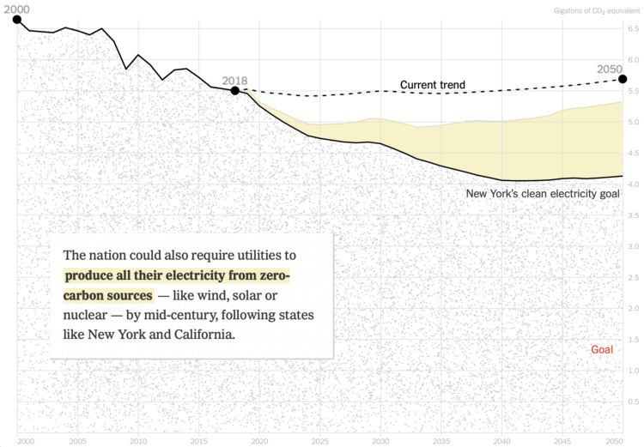

**Evaluation**

**Criteria 1**

A graph should have a zero baseline.

* This criteria does not apply to this graph.

**Criteria 2**

Colours should not be misuse or overused.

* Colours are well utilize to ensure this graph represent the data it is made to represent.

**Criteria 3**

Maximize data-ink ratio of your chart

**Criteria 4**

Cluttering should be avoided

* The graph cluttered with information can get a reader easily confused.

**Criteria 5**

The use of data markers are unnecessary

* This criteria does not apply to this graph.

**Criteria 6**

All axes should be labelled in simple and easy to understand terms. Scales should also be correctly illustrated.

* The axes are not properly labelled, so it is hard to say at a glance, what they represent.

**Recommendations**

* The graph should be de-cluttered to make it readable.
* The axes should be labelled appropriately for easy understanding of what they represent.

Graph 10: Global temperature vs. number of pirates

This chart shows how the disappearance of pirates has contributed to the rise in global temperature. It is obtained from Sisense.

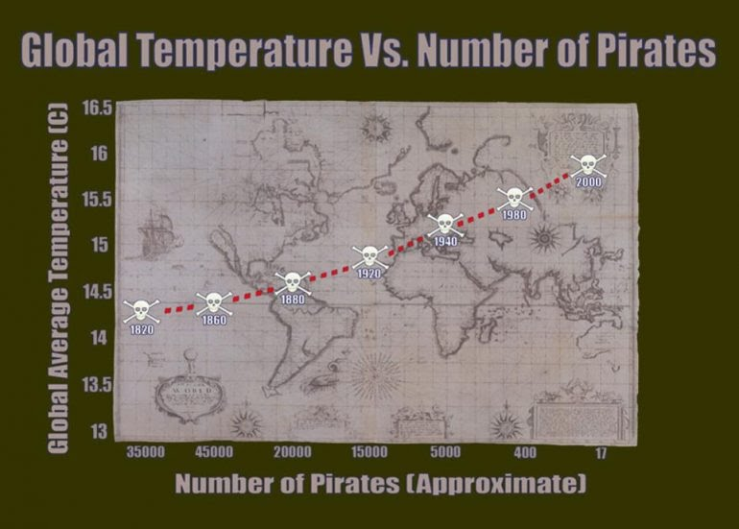

**Evaluation**

**Criteria 1**

A graph should have a zero baseline.

* The graph can easily misinterpreted as it does not have a baseline zero.

**Criteria 2**

Colours should not be misuse or overused.

* The colours have been properly combined to ensure the graph is readable.

**Criteria 3**

Maximize data-ink ratio of your chart

* The data-ink-ratio is not well maximized.

**Criteria 4**

Cluttering should be avoided

**Criteria 5**

The use of data markers are unnecessary.

* There are markers on the graph, but this is quite unnecessary.

**Criteria 6**

All axes should be labelled in simple and easy to understand terms. Scales should also be correctly illustrated.

* Axes well properly labelled in this graph. The scale is however poorly illustrated on the Y-axis.

**Recommendations**

* The clutters on the graph such as the background in the plot area.
* The markers should be removed to de-cluttered further.
* The scale on the Y-axis also be properly illustrated.

**Summary**

Data visualization is a field many experts such as Hal Varian has forecast to be one next big things (Kirk, 2012). If data is the oil, as it has been proclaimed, then data visualization is the engine that facilitates its true value (Kirk, 2012). With data visualization, we are able to tell our data story. While making the graphics representation, however, there is a need to follow best practices, so that the whole purpose of the data visualization will be defeated. In this task, we are able to critique published data visualizations using predefined criteria. Recommendations that can help improve on the graphs were also made.

# **References**

Duarte, N. (2010). *Resonate: Present Visual Stories that Transform Audiences.* Hoboken, NJ: Wiley & Sons.

Few, S. (2006). *Information Dashboard Design:The Effective Visual Communication of Data.* O'Reilly.

Kirk, A. (2012). *Data Visualization: a successful design process.* Packt Publishing Limited.

Knaflic, C. (2015). *Story Telling with Data: a data visualization guide for business professionals.* Hoboken, New York: John, Wiley & Sons, Inc.

Stone, M. (n.d.). Coosing colors. Retrieved from http://www.perceptualedge.com/articles/beye/choosing_colors.pdf

Tufte, E. (1983). *The Visual Display of Quantitative Information.* Chester, CT: Graphics Press.